**Pollution Incident Response Management Plan (PIRMP)**

|  |  |  |  |  |  |  |  |  |  |  |  |  |  |  |  |  |  |  |  |  |  |  |  |  |  |  |  |  |  |  |  |  |
| --- | --- | --- | --- | --- | --- | --- | --- | --- | --- | --- | --- | --- | --- | --- | --- | --- | --- | --- | --- | --- | --- | --- | --- | --- | --- | --- | --- | --- | --- | --- | --- | --- |
| **Environment Protection Licence**  **no: 11205**   |  |  |  |  |  | | --- | --- | --- | --- | --- | | **Testing of plan** | | | | | | **Date Tested** | **Tested by** | **Details of test** | **Date scheduled for next test** | **Issues identified** | | *29/03/2022* | *Keely Usher* | *Desktop simulation – chemical spill* | *29/03/2023* |  | | *22/04/2022* | *Keely Usher* | *Mock Spill Treatment Plant H2F Mixing* | *22/04/2023* | Possible spill exiting bunded area | |  |  |  |  |  | | | | | | | | |
|  |  | |  | |  | |  |
|  | |  | |  | |  | |

Contents

**Purpose and Background** 3

**Scope** 3

**Legislative Requirements** 3

**Terms and Definitions** 3

**Description of potential hazards and their likelihoods** 4

**Pre-emptive actions taken by DWAU** 7

**Inventory of Pollutants** 8

**Safety equipment** 9

**Contact details** 9

**Communication and Notification procedures** 10

**Emergency Spill Procedure** 11

**Staff training** 13

# **Purpose and Background**

Dongwha Australia Pty Ltd (DWAU) holds an Environment Protection Licence with the NSW Environment Protection Authority for 1 Sandy Lane, Bombala NSW. As per the *Protection of the Environment Operations Act (1997)* (The POEO Act), the holder of an environment protection licence must prepare, keep, test and implement a pollution incident response management plan that complies with Part 5.7A in relation to the activity to which the licence relates.

If a pollution incident occurs in the course of an activity so that material harm to the environment (within the meaning of section 147 of the POEO Act) is caused or threatened, the person carrying on the activity must immediately implement any Pollution Incident Response Management Plan in relation to the activity required by Part 5.7A of the POEO Act.

The purpose of this Management Plan is to provide a consistent and effective emergency response to any chemical spills which may impact on the site and its surrounding areas, including the control of water levels in our dams which may flow into neighbouring rivers and banks.

# **Scope**

This PIRMP covers DWAU’s Bombala sawmill facility. This plan applies to the whole site.

# **Legislative Requirements**

Specific legislative requirements for the development and implementation on this PIRMP are provided in the following table.

|  |
| --- |
| Part 5.7 A of the *Protection of the Environment Operations Act 1997 (POEO Act)* |
| Part 5.7 A of the *Protection of the Environment Legislation Amendment Act 2011 (POELLA Act)* |
| The *Protection of the Environment Operations (General) Amendment (Pollution Incident Response Management Plans)Regulation 2012* |
| Environment Protection License (EPL) 11205 |

# **Terms and Definitions**

Definition of a pollution incident

A pollution incident means an incident or set of circumstances during or as a consequence of which there is likely to be a leak, spill or other escape or deposit of a substance, as a result of which pollution has occurred, is occurring or is likely to occur .It includes an incident or set of circumstances in which a substance has been placed or disposed of on premises, but it does not include an incident or set of circumstances involving only the emission of any noise.

Abbreviations

|  |  |
| --- | --- |
| Abbreviation | Explanation |
| NSW EPA | New South Wales Environmental Protection Authority |
| PIRMP | Pollution Incident Response Management Plan |

MAKING THE PIRMP publicly available

A hard copy of the PIRMP is displayed in the Workshop, Green Mill, Treatment plant and the production office. There will also be an online version on the website.

TESTING THE PIRMP

Dongwha acknowledges that the PIRMP need to be tested and maintained to ensure the information is accurate and up –to-date, and the PIRMP can be implemented in a workable and effective way. The testing is done on site every year. Desktop simulation –chemical spill was done on 29th March 2021 and Mock spill was done at the Treatment Plant H2F Mixing area on 22nd April 2021.

In addition to the mock test, The PIRMP will also be tested within any month of any pollution incident. The resulting of all testing of the PIRMP will be recorded.

# **Description of potential hazards and their likelihoods**

Dongwha undertakes a risk assessment of their premises to identify hazards that needs to manage to minimise the potential for an incident.

Potential Chemical Hazards

Impretect CS (CCA oxide) is a dangerous good (class 8 sub-risk 6.1) and hazardous substance and should be handled with caution. All efforts should be made when handling Impretect CS (CCA oxide) to minimise contact as it can prove toxic to humans by ingestion, inhalation and skin contact.

CCA (Copper Chromium Arsenate) Wood Preservative can create a significant environmental hazard. It is a Dangerous Good under the Australian Commonwealth Government “Code of Transport of Dangerous Goods by Road and Rail” and under Relevant State Legislation.

It is a water-Bourne chemical and is not flammable, however heating of the liquid can produce toxic vapours, so care should be taken in the event of fire at the plant. In liquid form, CCA Wood Preservatives are acidic, with a pH range from 1.0 to 2.6.

The constituents of CCA will form insoluble complexes with an increase in pH, therefore becoming less mobile in alkaline conditions.

# **POTENTIAL HAZARDS**

Potential hazards include:

* Workshop
* Aboveground self bunded diesel tank
* Dust issues on site
* Effluent storage septic tanks

Dongwha has considered the other contributing circumstances that could contribute to a pollution incident. There are no commercial businesses around the site. There are neighbouring properties.

The circumstances include:

* Power Failure
* Fire
* Bushfire
* Vegetation and other combustible material along the premises
* Floods

# **RISK MATRIX**

Table 1 - Consequences

|  |  |  |
| --- | --- | --- |
| **Level** | **Descriptor** | **Consequences examples** |
| 1 | Catastrophic | Long Term environmental damage ( 5 years or Longer) , requiring $5 million to correct |
| 2 | Major | Medium-term (1-5 years) environmental damage , requiring $1 to 5 million to correct |
| 3 | Moderate | Short-term (less than 1 year) environmental damage , requiring 150,000 to 1 million to correct |
| 4 | Minor | Environmental damage , requiring up to $100,000 to correct |
| 5 | Insignificant | Negligible environmental impact , managed with operational budget |

Table 2 –Likelihood

|  |  |  |  |
| --- | --- | --- | --- |
| **Level** | **Descriptor** | **Likelihood of the risk arising and leading to the assessed level of consequence** | **Frequency** |
| A | Almost certain | Is expected to occur in most circumstances and has a history of occurrence | Once a year or more frequent |
| B | Likely | Will probably occur in most circumstances | Once in 1 to 3 years |
| C | Possible | Could occur at the same time | Once in 3 to 10 years |
| D | Unlikely | Not Likely to occur in normal circumstances | Once in 10 to 50 years |
| E | Rare | May occur only in exceptional circumstances | Once in 100 years or more |

Determine the risk level

Table –Risk Matrix

|  |
| --- |
| **Consequences** |

|  |  |  |  |  |  |
| --- | --- | --- | --- | --- | --- |
| **Likelihood** | **Catastrophic**  **1** | **Major**  **2** | **Moderate**  **3** | **Minor**  **4** | **Insignificant**  **5** |
| Almost certain  A | Extreme | Extreme | High | High | Medium |
| Likely  B | Extreme | Extreme | High | Medium | Low |
| Possible  C | Extreme | High | Medium | Medium | Low |
| Unlikely  D | High | Medium | Medium | Low | Low |
| Rare  E | High | Medium | Low | Low | Low |

|  |  |  |  |  |
| --- | --- | --- | --- | --- |
| **RISK** | **LIKELIHOOD** | **CONSEQUENCE** | **RISK RATING** | **ACTION** |
| Oil spillage at Workshop | Possible | Insignificant | Low | Clean –up using spill kits |
| The forklifts/any other vehicle on site hitting above ground self bunded diesel tank. This could cause diesel leak. | Possible | Insignificant | Low | Clean-up |
| Dust issues on site | Likely | Moderate | High | Water cart will be more regularly used. Some of the operations will be halted as well. Dustex is also in place to be used. |
| Effluent storage septic tanks. There can be overflow. | Rare | Low | Insignificant | Clean –up and also contact the Waste contractor to transport the waste off site. |
| CCA Oxide spillage | Possible | Minor | Medium | Will do the clean up using the spill kits |
| H2F Spillage | Possible | Minor | Low | Will do the clean up using the spill kit |

# **Pre-emptive actions taken by DWAU**

* An **environmental management strategy** is in place , quality assurance and quality control programs and preventative maintenance procedures
* There is an above ground bunded storage diesel tank and also other bundings where the liquids are stored
* There are alarms/notification systems in the green mill , satellite , dry mill and other areas
* **UHF radios** are used very well for alerting people on site when an incident occurs
* Standard operating procedures have been developed , used and maintained by the WHS officer
* There are restricted access areas which can be accessed only by trained and highly qualified people.
* There are installation and storage of supplies for combatting an incident. There are **spill containment kits** in different parts of the site, the installation and operation of stormwater cut-off valves and fire water tanks.
* **Air monitoring** is regularly done on the boiler stacks and pumps. Soil and water monitoring is also done. There are also groundwater monitoring wells on the site. Tests are all regularly done.
* **Noise tests** are done annually and is part of the environmental protection license. Various noise implementation strategies have been introduced to the site like Noise barrier wall for log sorting line, an enclosure for the wood chipper and rolling shutter door for the satellite. All these efforts are to combat to higher noise level on site.
* **Stormwater** on site is managed by capturing all of the stormwater generated at the site in three ponds – Northern Pond, Pond 1 and Pond 2. Ground contours, silt trap and automatic pumps have been installed as part of the development. The automatic pump will assist the flow of water into Pond 1 and pump it into Pond 2 to avoid overflow. Pond 1 will be operated as a dry pond.

This way in an event of emergency/flood, pond 1 will offer additional storage capacity. In combination, both pond 1 and 2 can contain uncontaminated water, and will have sufficient capacity to contain 144 hour rainfall event. While the northern pond which has the potential to capture contaminated storm water, also will have sufficient storage capacity to capture a 1 in 100, 72 hour storm event, which is a rarity (1% chance).

Should a 72-hour rainfall event occurs at site, there is the potential for off-site discharge to occur from the northern pond. In this event, the very significant volume of run-off is likely to dilute any contaminant concentrations in the run-off. This will be considered low-risk impact. Water balance also suggests that the Northern pond will be dry for a significant time, indicating that northern pond will be easy to mobilise during an extreme rainfall event.

* Wastewater management is an integral process of DWAU site. The following are the wastewater streams;

1. Condensate generated from Redry kilns and boilers
2. Sewage generated on site
3. CCA waste generated within the treatment plant

* DWAU has strongly committed towards better **dust management** on site. The main areas concerning DWAU are Despatch, Maintenance/workshop, Dry Mill, Satellite, Green mill, Log yard and other roads. As there are dust emissions on site, DWAU has a dedicated water cart which is used for dust suppression purposes. The water is used from the dam on site.

The site’s exit road is being swept every fortnight. It is through this road, where number of trucks exit up to 6 days per week. During summer time, the sweeping is reviewed and then depending on the dust accumulation on road there might be change in frequency of exit road sweeping.

Dustex is also applied on site as required. Dustex is a product derived from wood pulping process and used specifically for dust control purposes.

Extreme windy days can lead up to higher dust accumulation. Main source of dust emissions on site are unsealed roads and vehicular movements on these roads and the loading area.

* **Independent audit** is done by an independent auditor every 3 years. While, Inspection of systems and procedures are regularly done. There are also monthly checklists which are submitted by the leading hands of the respective departments.

# **Inventory of Pollutants**

The table below describes the pollutants on site.

|  |  |
| --- | --- |
| Chemical spill/Leak  Quantities of chemicals are stored onsite | Capacity |
| LOSP Concentrate stored at treatment plant in tanks | 70,000 L |
| CCA oxide stored at treatment plant in tank | 26,000L |
| Mouldicide stored in IBC at treatment plant | 2,000L |
| Hydraulic /gear/engine oils in drums at warehouse | 10,000 L |
| Diesel Fuel stored in self bunded storage tank in Yard | 70,000 L |
| Water softener chemical stored in Redry Boiler | 200 L |
| Lubricant stored in drums at dry mill for Moulder use | 400 L |
| Lubricant stored in workshop for mobile plant use | 400 L |
| Hydraulic oil in Green Mill (4 hydraulic packs) | 3000 L |
| H2F RTU Work solution (H2F Bifenthrin ) stored in a bunded area at Treatment plant area | 3000 L |
| H2F Concentrate (H2F Bifenthrin ) stored in a bunded area at Treatment plant area | 20 x 20L |

# **Safety equipment**

* There are specific gloves for certain types of corrosive chemicals
* Other Personal protective equipment like Hazmat suits, Disposable ear plugs, Disposable dust masks, Safety Hi-vis and other protective gears.
* There are also gauges on tanks
* There are alarms in place when there are issues with processes
* Firefighting equipment for when there Is a fire
* Safety data sheets for all the chemicals in use for the treatment of timber
* Hard hats for emergency controllers
* Eye-wash stations and showers
* Emergency backup generator for the biomass boiler and main office
* Safety equipment and other devices are stored in the production office.
* The up to date safety data sheets for any chemicals/fuels are stored in Production office and treatment plant. They are also digitally stored on the company cloud.

# **Contact details**

The below tables mentioned are the 24 hour contact details of the key individuals who are

* Responsible for activating the PIRMP
* Authorised to notify relevant authorities , including all five relevant authorities under section 148 of the POEO Act
* Responsible for managing the response to a pollution incident

**Primary Contacts**

|  |  |  |
| --- | --- | --- |
| **Name** | **Position** | **Contact number** |
| Glen Hampshire | Production Manager | 0408583936 |
| Scott Newman | WHS & Compliance Supervisor | 0431444280 |

**Neighbour’s contact**

|  |  |  |
| --- | --- | --- |
| Fran & Antony Beck | Straw Services | 0417273313 |

# **Local and other relevant authorities**

The occupier of premises, the employer or any person carrying on the activity which causes a pollution incident to immediately notify each relevant authority (identified below) when material harm to the environment is caused or threatened. The following information and procedures may assist those responsible for reporting a pollution incident.

Firstly, call 000 if the incident presents an immediate threat to human health or property. Fire and Rescue NSW, the NSW Police and the NSW Ambulance Service are the first responders, as they are responsible for controlling and containing incidents.

If the incident does not require an initial combat agency, or once the 000 call has been made, notify the relevant authorities in the following order. The 24-hour hotline for each authority is given when available:

* Local Council - Snowy Monaro Regional Council – 1300 345 345
* Department of Planning and Environment -1300 305 695
* NSW EPA (Environment Line on 131 555 )
* The Ministry of Health via Goulburn Public Health Unit – (02) 4824 1837 and after hours on (02) 6080 8900 (Albury Base Hospital-ask for public health officer on call)
* Safework NSW (formerly WorkCover) – phone 13 10 50
* Fire and Rescue NSW – phone 1300 729 579

Note: If the situation warranted calling 000 as a first point of notification, you do not need to ring Fire and Rescue NSW again.

# **Communication and Notification procedures**

Communicating with neighbors and local community

During an emergency situation, it could be necessary to communicate the state/type of the emergency, the possible cause, its effects/consequences, likely duration and impact to potential stakeholders.

Those early warning and updates will ensure the stakeholders have the information needed to minimise any risk of harm from the incident.

All information that is communicated to external stakeholders must be authorised by Glen Hampshire (Primary Contact listed in previous section) Decisions to notify neighbours and the local community will be made in consultation with regulatory authorities. The only immediate neighbour is Straw services which is a sawdust supplier.

Stakeholders that may require notification include:

1. Neighbours , local landowners and community representatives;
2. Dongwha employees and family members;
3. Media;
4. Insurers and lawyers

Methods of communication to the community include:

1. Personal visits;
2. Letter box drops and newsletters;
3. Emails to community representatives;
4. Local radio announcements
5. Newspaper advertisements; and
6. Telephone calls , SMS or other messaging systems

Dongwha Australia Pty Ltd must identify owners or occupiers of premises in the vicinity of the premises to which the environment protection licence or the direction under section 153B of the POEO Act relates.

DWAU does not just rely on emergency services. An effort will be made to contact and communicate with neighbours.

# **Emergency Spill Procedure**

In the event of an emergency chemical spill, UHF radios will be used to notify personnel. At all times during operations like CCA emergencies, whether contained spill or emergency spill. Minimum protective clothing must be worn are:

* Impervious Gloves
* Disposable overalls (preferably waterproof) or impervious apron.
* Respirator mask
* Safety footwear gum boots (leather is not ideal)
* Chemical goggles or eye protection with side shields
* Protective clothing

If there is a requirement to evacuate the site, workers must:

* Leave the site immediately by the nearest exit
* Proceed to the assembly area
* Remain in the assembly area until advised the emergency is over
* Not re-enter the site until advised it is safe to do so

In the event of an emergency spill that is not contained by site personnel do not hose down spill outside bunded area. The plant operator and other trained personnel shall:

1. Ensure all personal protective equipment is worn

2. Alert Emergency Controller or a member of his/her team who shall alert relevant internal or external parties (such as fire brigade and emergency services)

3. Stop the spill at its source to prevent further spillage (if safe to do so)

4. Shut down relevant equipment

5. Contain spillage with sand, earth or vermiculite.

6. Clear area of personnel and move up-wind (set up witches’ hats or bunting around area).

7. Prevent spillage from entering drains or dams.

8. Contact Waste Disposal Provider to collect any recoverable chemical.

9. Neutralise/decontaminate chemical residues using lime.

10. Collect soil residues and place into approved labelled drums.

11. After clean-up operations, ensure to decontaminate and launder all protective clothing and equipment before re-using.

12. Investigate the cause of incident to prevent from re-occurring.

13. Engineering / Compliance Manager to inform EPA and other relevant authorities of the incident and corrective action.

14. Contact immediate neighbours

15. Monitor any environmental effects.

**Water in Dam**

Should the dam on Delegate Road be filled with water, Dongwha Australia will ensure it is regularly maintained to a low level and not overflowing onto neighbouring rivers or banks. Sandbags may also be used to control the overflowing of water if required.

**Minimising harm to people**

* In the event of an emergency chemical spill of CCA Wood Preservative, the following equipment should be readily available.
* Dry sand, earth, vermiculite or other clean, dry inert material of sufficient quantity to create containment Bunding around the area.
* Lime of sufficient quantity to cover the spill CCA so as to neutralise all of the spilt liquid.
* Shovels, brooms
* Sheets of plastic to cover drains
* Witches hats or bunting to mark out emergency area and to keep unauthorised personnel out of the area.
* Approved containers / drums to store the recovered waste (ensure correct labels are on the drums).

# **Staff training**

Various members of staff are current members of the Rural Fire Service (RFS) and Retained Fire Fighters and have obtained various certificates of attainment through the RFS pertinent to fire suppression methods.

All site fire wardens have undergone training as wardens as well as training on the use of fire extinguishers.

Local combat agencies and emergency response organisations have all indicated interest to be involved in annual training exercises on site which will ensure combat agencies and emergency response organisations remain familiar with site conditions as well as assets.

Relevant exercises will be arranged by the Work Health Safety Officer on site.

**DONGWHA AUSTRALIA**

**HAZARDOUS SUBSTANCE LOCATIONS**

**GPS Co-ordinates Latitude: -36.93048 Longitude: 149.21133**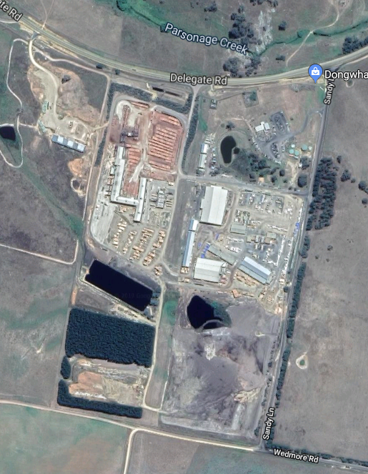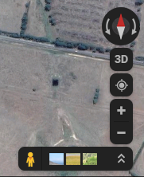

Location #4

Location #3

Manifest Location

Location #1

Location #2

Water Way

**DONGWHA AUSTRALIA BOMBALA SITE**

**STORAGE LOCATIONS & CAPACITIES**

|  |  |  |  |  |  |  |  |  |
| --- | --- | --- | --- | --- | --- | --- | --- | --- |
| **SITE MAP**  **IDENTIFIER** | **STORAGE TYPE** | **GOODS** | **UN #** | **CLASS** | **PACKING GROUP** | **HAZCHEM CODE** | **MAX CAPACITY** | **ACTUAL CAPACITY** |
| **1** | **C:\Scotty\Dongwha\Photos\Roofed tank farm 15 Oct 19.jpg** | **Koppers LOSP** | **N/A** | **N/A** | **N/A** | **N/A** | **70,000L** | **70,000L** |
| **1** | **C:\Scotty\Dongwha\Photos\Roofed tank farm 15 Oct 19.jpg** | **CCA Oxide Work Solution** | **N/A** | **N/A** | **N/A** | **N/A** | **70,000L** | **70,000L** |
| **1** | **C:\Scotty\Dongwha\Photos\Roofed tank farm 15 Oct 19.jpg** | **Osmose Sarmix Oxcell C680o** | **UN**  **2922** | **C:\Scotty\Safety Sign Clip Art\Hazchem\JPG 72dpi\haz16.jpg** | **III** | **2X** | **26,000L** | **17,000L** |

**DONGWHA AUSTRALIA BOMBALA SITE**

**STORAGE LOCATIONS & CAPACITIES**

|  |  |  |  |  |  |  |  |  |
| --- | --- | --- | --- | --- | --- | --- | --- | --- |
| **SITE MAP**  **IDENTIFIER** | **STORAGE TYPE** | **GOODS** | **UN #** | **CLASS** | **PACKING GROUP** | **HAZCHEM CODE** | **MAX CAPACITY** | **ACTUAL CAPACITY** |
| **1** | **C:\Scotty\Dongwha\Photos\Roofed tank farm 15 Oct 19.jpg** | **Osmose Micropro Work Solution** | **N/A** | **N/A** | **N/A** | **N/A** | **70,000L** | **70,000L** |
| **2** | **C:\Scotty\Dongwha\Photos\Treatment IBC's 15 Oct 19.jpg** | **Osmose Micropro 200c** | **UN**  **3082** | **C:\Scotty\Safety Sign Clip Art\Hazchem\JPG 72dpi\haz16.jpg** | **III** | **2X** | **12,000L**  **(12 x 1000L)** | **12,000L** |
| **2** | **C:\Scotty\Dongwha\Photos\Treatment IBC's 15 Oct 19.jpg** | **Koppers CMIT 14%** | **UN**  **2922** | **C:\Scotty\Safety Sign Clip Art\Hazchem\JPG 72dpi\haz15.jpg** | **II** | **2XE** | **2,000L** | **2,000L** |

**DONGWHA AUSTRALIA BOMBALA SITE**

**STORAGE LOCATIONS & CAPACITIES**

|  |  |  |  |  |  |  |  |  |
| --- | --- | --- | --- | --- | --- | --- | --- | --- |
| **SITE MAP**  **IDENTIFIER** | **STORAGE TYPE** | **GOODS** | **UN #** | **CLASS** | **PACKING GROUP** | **HAZCHEM CODE** | **MAX CAPACITY** | **ACTUAL CAPACITY** |
| **2** | **C:\Scotty\Dongwha\Photos\Treatment IBC's 15 Oct 19.jpg** | **Micronised Tebuconazole**  **(73G/L)**  **Pre-Mix** | **UN**  **3082** | **C:\Scotty\Safety Sign Clip Art\Hazchem\JPG 72dpi\haz16.jpg** | **III** | **•3Z** | **10,000L** | **5,000L** |
| **3** | **C:\Scotty\Dongwha\Photos\Diesel Tank.jpg** | **Diesel** | **UN**  **3082** | **C:\Scotty\Safety Sign Clip Art\Hazchem\JPG 72dpi\haz16.jpg** | **III** | **N/A** | **70,000L** | **45,000L** |
| **4** | **K:\04. Safety\Pictures\Treatment Plant\Treatment Plant Location 4.jpg** | **Koppers H2F Concentrate** | **UN**  **3082** | **C:\Scotty\Safety Sign Clip Art\Hazchem\JPG 72dpi\haz16.jpg** | **III** | **•3Z** | **20 x 20L** | **400L** |
| **4** | **K:\04. Safety\Pictures\Treatment Plant\Treatment Plant Location 4.jpg** | **Koppers H2F Work Solution** | **N/A** | **N/A** | **N/A** | **N/A** | **3000L** | **3000L** |

**TANK FARM LOCATION #1**

**Fully Bunded Roofed Bunker (3 x 70K Litre & 1 x 26K Litre)**

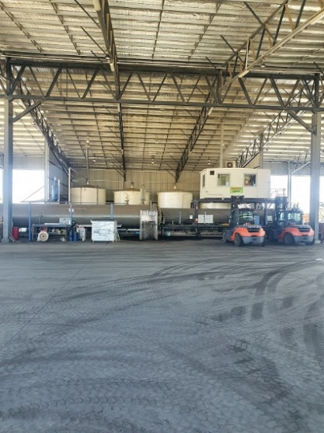

**LOCATION # 2**

**Bunded Roofed Store (24 x 1000L IBC’s)**

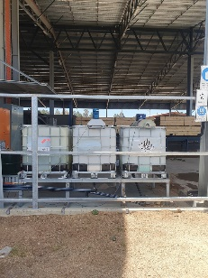

**LOCATION # 3**

**Self-Contained Storage (1 x 70K Litre)**

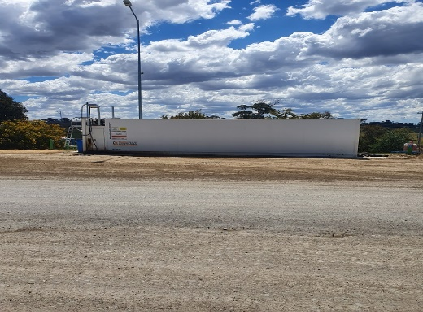

**LOCATION # 4**

**Bunded Roofed Store 20 x 20L H2F Concentrate**

**5 x 800L H2F Work Solution**

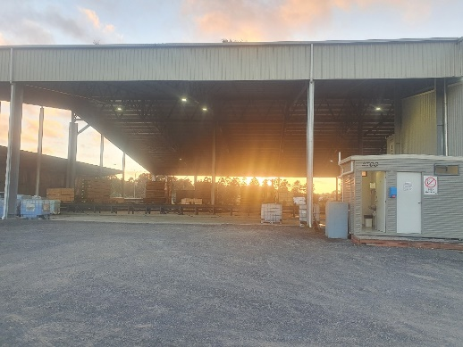

**DWAU Site map with environmental monitoring locations as per EPL 11205**

